

HEIGHT & CAMBER ADJUSTMENT

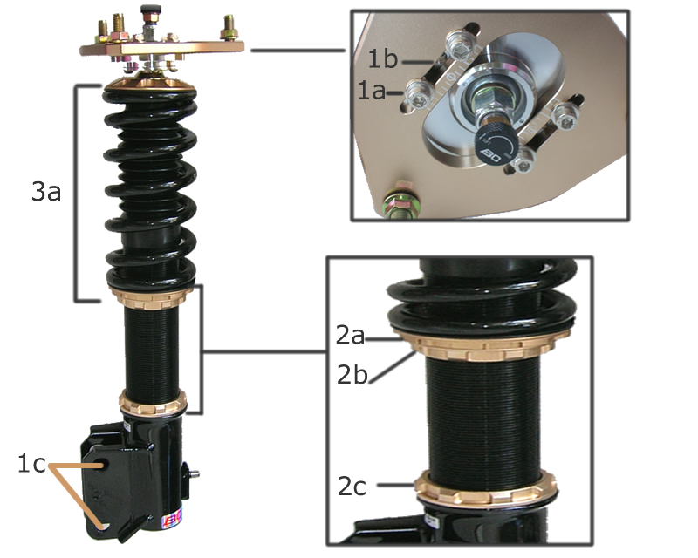

NOTE: All springs come preloaded from the factory (3a). If for any reason the spring becomes loose, tighten the seat (2a) until the spring sits snug and lock (2a and 2b) in place. Do not over tighten spring as this will compress spring and cause rate shifting. Maximum compression of springs should be 5mm.

For all height adjustments, always adjust from the lower lock ring (2c), not from the lower spring seat (2a,b). By doing this, you will not alter the suspension travel. At any drop, 3a should always remain the same.
Height adjustments:
Height adjustments can be made after you install the system on the car.
1. Make sure both 2a and 2b are tight. These are locked against each other.
2. Loosen lower lock ring (2c).
3. Using the spanner wrenches that comes with the kit, turn the upper spring seat (2a) counter clock-wise (right to left) to lower or the lower lock ring (2b) clock-wise (left to right) to raise the vehicle.
4. After you achieve your desired height, make sure you tighten the lower lock ring (2c) before you drop the vehicle to the ground.

NOTE: You may need to repeat steps 2-4 a few times until you achieve the desired height. It is suggested you do one side front and rear first and then measure from 2b to 2c and copy to other side. This will save time on install.

Camber adjustment:
- Loosen both lower strut bolts (1c).
- Loosen all 4 upper allen (1a) bolts from camber plate.
- If for any reason more adjustment is needed, additional accessory holes are located (1b) to allow for further range of adjustment.
- Once desired camber is achieved tighten the upper 4 allen bolts (1a) and lower 2 strut bolts (1c).

